ONLINE INTERNSHIP PROCESS ADMINISTRATION SYSTEM
ABSTRACT

Internship process for students is web application it helps to process internship work through online. An internship experience combines hands-on workplace experience with your discipline-specific skills, and earns academic credit towards your course. Arranging your internship involves three steps: preparing, securing, and registering. An internship experience combines hands-on workplace experience with your discipline-specific skills, and earns academic credit towards your course. Arranging your internship involves three steps: preparing, securing, and registering.

As the Internship in Online accessibility software, “INTERNSHIP PROCESS ADMINISTRATION SYSTEM” has helped students to view the company’s availability of vacancies in internship, how to apply the procedure and techniques details are easily track through this website process, and also they check of interviews available for internship, company can post their requirement.

This project is aimed at developing by using JAVA as Front end and MySQL Server as Back end.
SYSTEM SPECIFICATION
HARDWARE SPECFICATION
- Processor : P 4 700 GHz.
- RAM : 4 GB RAM
- Hard Disk Drive : 180 GB

SOFTWARE SPECIFICATION
- Operating System : Windows 7/8/10
- Front End : JAVA
- Back End : SQL

MODULE AND ITS DESCRIPTIONS

Admin
The Company Administration Login consists of the upload all the details of their companies for students and conducting interview details, up to student upload their source code and verify admin process is through online mode.

View all applicants
In this module admin checks out the applicants that are registered through the portal and apply for internship.

Project Requirements
For the selected candidate’s admin precedes their requirement in project through this portal and gives to student portal

Apply Internship / Check date
After final their company where the vacancies of internship are avail, they can apply internship and check the date of interview to proceed.

Upload Source Code
Source code is uploaded by the student, after uploaded the final process of receiving completion letter is uploaded by the company administrator and views the letter through this portal or candidate mail.

Data Flow Diagram / USE Case Diagram

LEVEL 0
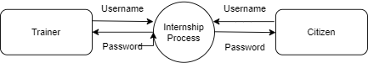

Level 1

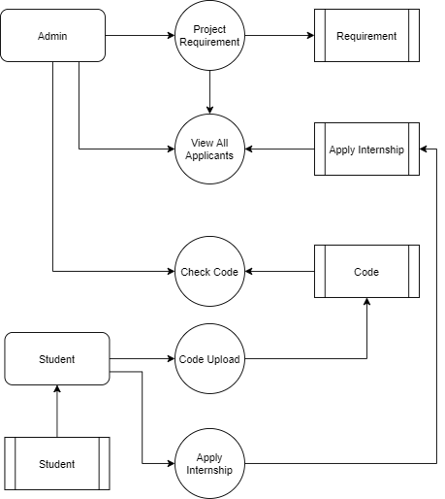

ER Diagram
